

**MSPM’S**

**Deogiri Institute of Engineering and Management Studies, Aurangabad**

**Department of Computer Science And Engineering**

Report on

**ASUS Tuf Gaming FX505DT Laptop**

Submitted By

**Kunal Yashwant Pagore (26145)**

Under the Guidance of

**Prof.P.H.Durole**

Department of Computer Science And Engineering

(Deogiri Institute of Engineering and Management Studies)

**ASUS TUF Gaming FX505DT**



**Specification**

* Processor: AMD Ryzen 5-3550H processor,
* 2.1GHz Base speed (6MB cache, up to 3.7GHz)
* Memory & Storage: 8GB DDR4 2666MHz RAM upgradeable upto 32GB RAM with| NVIDIA GeForce GTX 1650 GDDR5 4GB VRAM Graphics| Storage: PCIe NVMe 512GB M.2 SSD
* Display: 15.6" (16:9) LED-backlit FHD (1920x1080) 120Hz Anti-Glare IPS-level Panel with 45% NTSC
* Operating System: Pre-loaded Windows 10 Home with lifetime validity
* Design & battery: 6.5mm Thin bezel | Laptop weight 2.20kg | Lithium battery 3-Cell
* Hypercool Technology: Anti-Dust Cooling | Powerful Dual Fan Design | HyperFan| Patented Trapezoid-cut Lid
* Keyboard: Highlighted WASD key group| All-zone RGB Backlight| 20 Million Key Presses | 1.8mm Key Travel| 0.25mm Keycap Curve| Overstroke Technology| HyperStrike technology
* Audio : DTS Headphone:X technology| Authentic 7.1-Channel Surround Sound| Audophile-Grade Equalizer Sound| Optimized Game/ Movie/ Sports Audio Profile
* I/O Ports : 1x 3.5mm Comba audio jack | 1 x Type-A USB 2.0| 2x Type-A USB 3.1 (Gen 1)| 1x RJ45 LAN jack for LAN insert | 1x HDMI 2.0
* Other: Tested and certified to meet military-grade MIL-STD-810G standards| Wi-Fi 5(802.11ac)| Kensington lock| HD 720p CMOS module Webcam

Warranty: This genuine Asus laptop comes with 1 year Global Warranty and Onsite Domestic Warranty. For more details, see warranty section

Display: Bright and smooth

High-refresh rate displays were earlier limited to only premium gaming laptops. And as usual, the same technology has now trickled down to the mid-range segment. The FX505DT comes with a panel with a refresh rate of 120 Hz and it’s a huge step up from using a regular 60 Hz panel.

[](https://images.firstpost.com/wp-content/uploads/2019/06/asus-tuf-gaming-fx505dt-1.jpg)

The display with a 1920 x 1080 pixel resolution is adequately bright. Image: tech2/Omkar Godambe

Everything feels smoother, especially moving the cursor on Windows. But that’s not where the display shines. Games look much better on a display with a higher refresh rate and sometimes, you might even choose this over colour accuracy. On the FX505DT, the display reproduces colour quite accurately and because of the IPS panel, the viewing angles are wide as well.

The brightness is appropriate for use even in daylight. I managed to get some work done while travelling in a cab on a bright sunny day and the brightness was adequate enough.

With a 15.6 inch display with a 1920 x 1080 pixel resolution, your gaming experience will be good.

[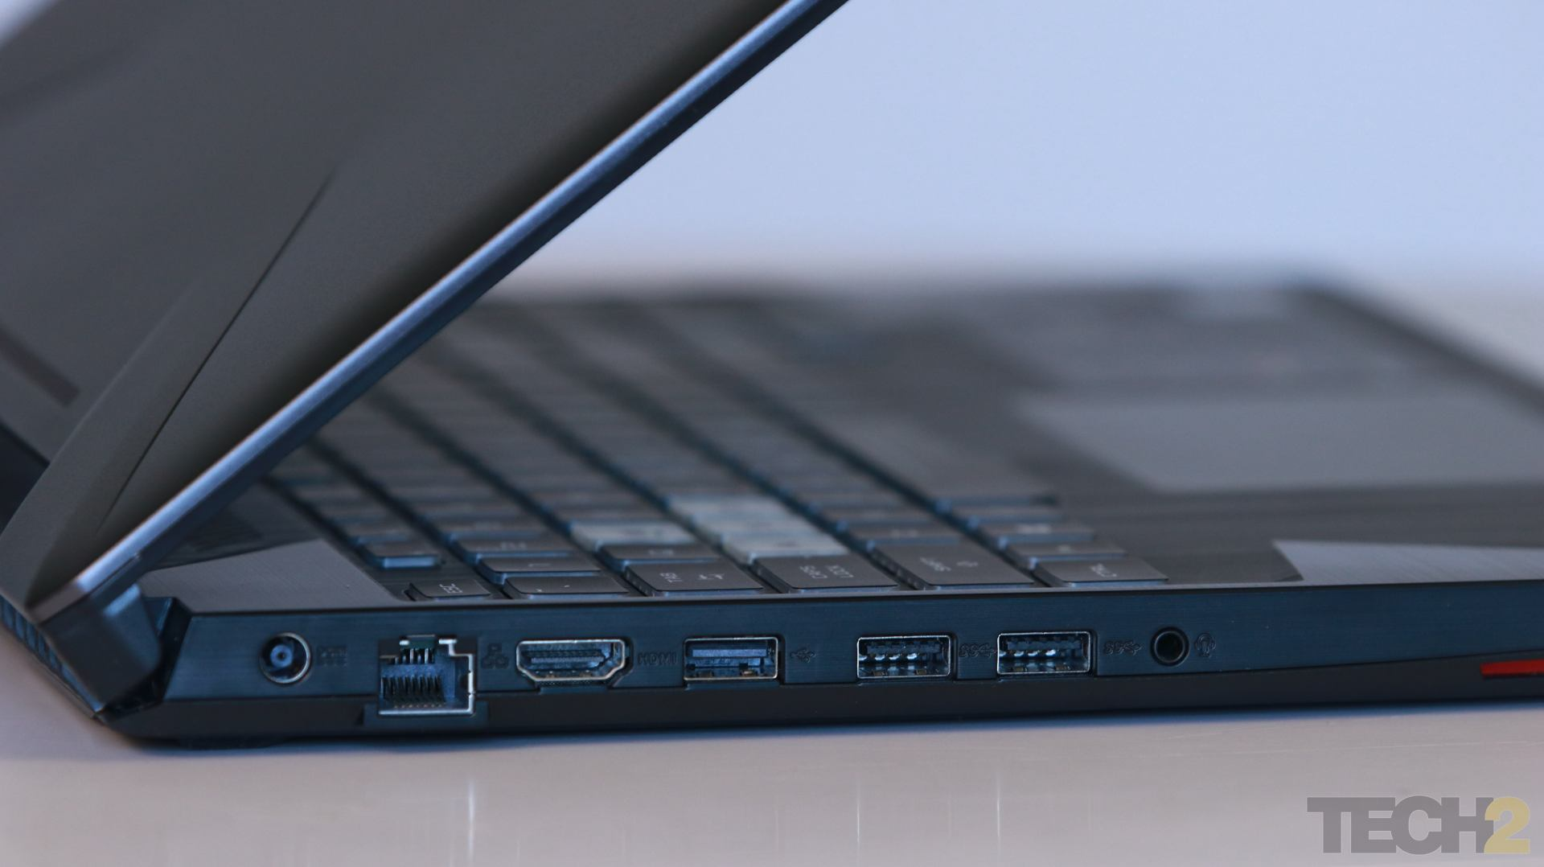](https://images.firstpost.com/wp-content/uploads/2019/06/asus-tuf-gaming-fx505dt-2.jpg)

Performance: 1080p 60 fps gaming on major titles

With the Ryzen 7 3750H and GTX 1650, the laptop is capable of running most of the gaming titles at medium to high settings. While games such as *Counter-Strike: Global Offensive*, *Dota 2*, *Fortnite*, *Apex Legends*, *DOOM*, etc., could comfortably push more than 100 fps at the highest settings, newer graphics-intensive games including *Metro: Exodus*, *Tom Clancy’s The Division 2* and *Battlefield V* ran above 30 fps at ultra settings. Bring the graphics quality down to medium, and the laptop pushes 60 fps comfortably. Essentially, the laptop can handle all the latest games at a decent frame rate that’s above 30 at the highest settings available.

Heating isn’t an issue with the laptop since it doesn’t affect gaming performance. However, the laptop does get hot towards the right side of the keyboard. Laptops usually have little headroom to dissipate the heat generated from the CPU and GPU, and this isn’t uncommon. But I’m glad it occurs on the right side and not below the WASD keys since you’ll be heavily using those keys while playing games. When the fans kick in during gaming sessions (sometimes randomly on opening *Google Chrome*), they do tend to get loud.

[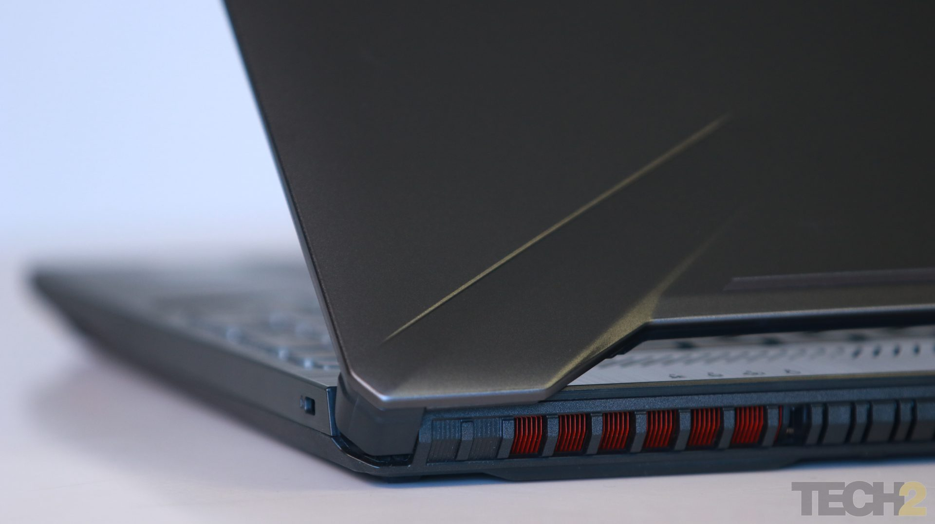](https://images.firstpost.com/wp-content/uploads/2019/06/asus-tuf-gaming-fx505dt-3.jpg)

There are vents for air circulation on the bottom and behind the main chassis of the laptop. Image: tech2/Omkar Godambe

I liked how the airflow has been designed in the laptop so that the two vents are on the bottom and behind the chassis. The absence of vents on the right side makes it comfortable to place the mouse on the same side without worrying about hot air blowing out.

Another design choice that I liked was the placement of all the ports on the left side. This again makes it comfortable to use a mouse on the right side without any hindrance from connected cables or devices.

The laptop has downward-firing speakers and they sound the best when placed on a flat surface. So, when it's on your lap, it doesn't sound good enough. The speakers also could have been louder.

[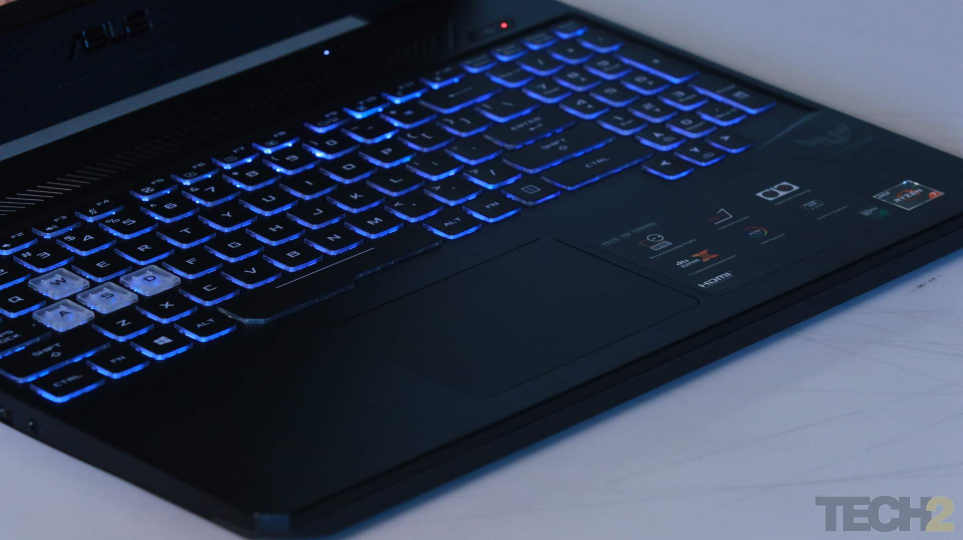](https://images.firstpost.com/wp-content/uploads/2019/06/asus-tuf-gaming-fx505dt-5.jpg)

The trackpad could have been way better. Image: tech2/Omkar Godambe

Not everyone will like the trackpad since it does feel flimsy at times. Tracking is accurate but sometimes it would lag, and I believe it has to do with Windows rather than this being a hardware issue. You're better off using a mouse for regular usage.

Battery life was surprisingly good. While I’ve seen gaming laptops dish out a couple of hours on battery, the FX505DT managed three hours in the PCMark 8 battery test in the Creative mode. On average, I was able to get close to three hours of battery life in continuous gaming sessions.

Software: Gets the job done

Asus has updated its central software that lets you monitor various system parameters such as CPU and GPU load, temperatures and fan speeds in real time. Earlier called 'ROG Armoury', the new utility is now known as 'ROG Armoury Crate' and it comes pre-installed.

Apart from checking your system parameters, the software can be used to change the backlighting of the keyboard. There are a few preset lighting effects already present that can be further customised according to your colour and transition speed preferences.

[](https://images.firstpost.com/wp-content/uploads/2019/06/asus-tuf-gaming-fx505d-4.jpg)

RGB lighting on the keyboard can be controlled using the ROG Armoury Crate utility. Image: tech2/Omkar

You can also control the fan speed profiles based on when the laptop is running on battery or while plugged in. The laptop’s HyperFan cooling technology can be toggled between different modes based on your usage.

ROG Armoury Crate also has a mobile companion app that will allow you to monitor the same system parameters and change the fan speed profile. While the app works, it erratically gets disconnected from the desktop utility when the app is closed or the phone’s screen turns off.

Verdict: Packing the essential features

The Asus TUF Gaming FX505DT ensures that an essential set of components and features are delivered so that your gaming experience is pleasant. This includes the high-speed PCIe Gen3 SSD storage, discrete graphics card and a full HD display with a refresh rate of 120 Hz. It manages to run most of the gaming titles you throw at it comfortably, although at medium to high graphics settings.

Having tested and used a few budget gaming laptops myself, I'd always find something or the other amiss in the design. This could be a poorly calibrated display or painfully slow storage. The FX505DT makes none of those mistakes and makes for a very satisfying gaming laptop, especially if you have a budget of Rs 80,000.

**THE GOOD**

* well made, nice design lines
* gets a matte 144 Hz IPS screen
* good keyboard and trackpad
* runs quiet with daily use
* solid performance with games, but the CPU/GPU run very hot
* very fast wireless
* should be affordable

**THE BAD**

* loud fans with games and other demanding loads
* average speakers
* only gets a 48 Wh battery

## Noise, Heat, Connectivity, speakers and others

On a first look, the cooling Asus implemented on the FX505 is [identical to the one on the FX504 line](https://www.ultrabookreview.com/19725-asus-tuf-fx504ge-review/#a7), with two fans, two radiators and two heat-pipes, a thicker one that covers both the CPU and GPU, as well as an extra skinnier heat-pipe for the GPU.

[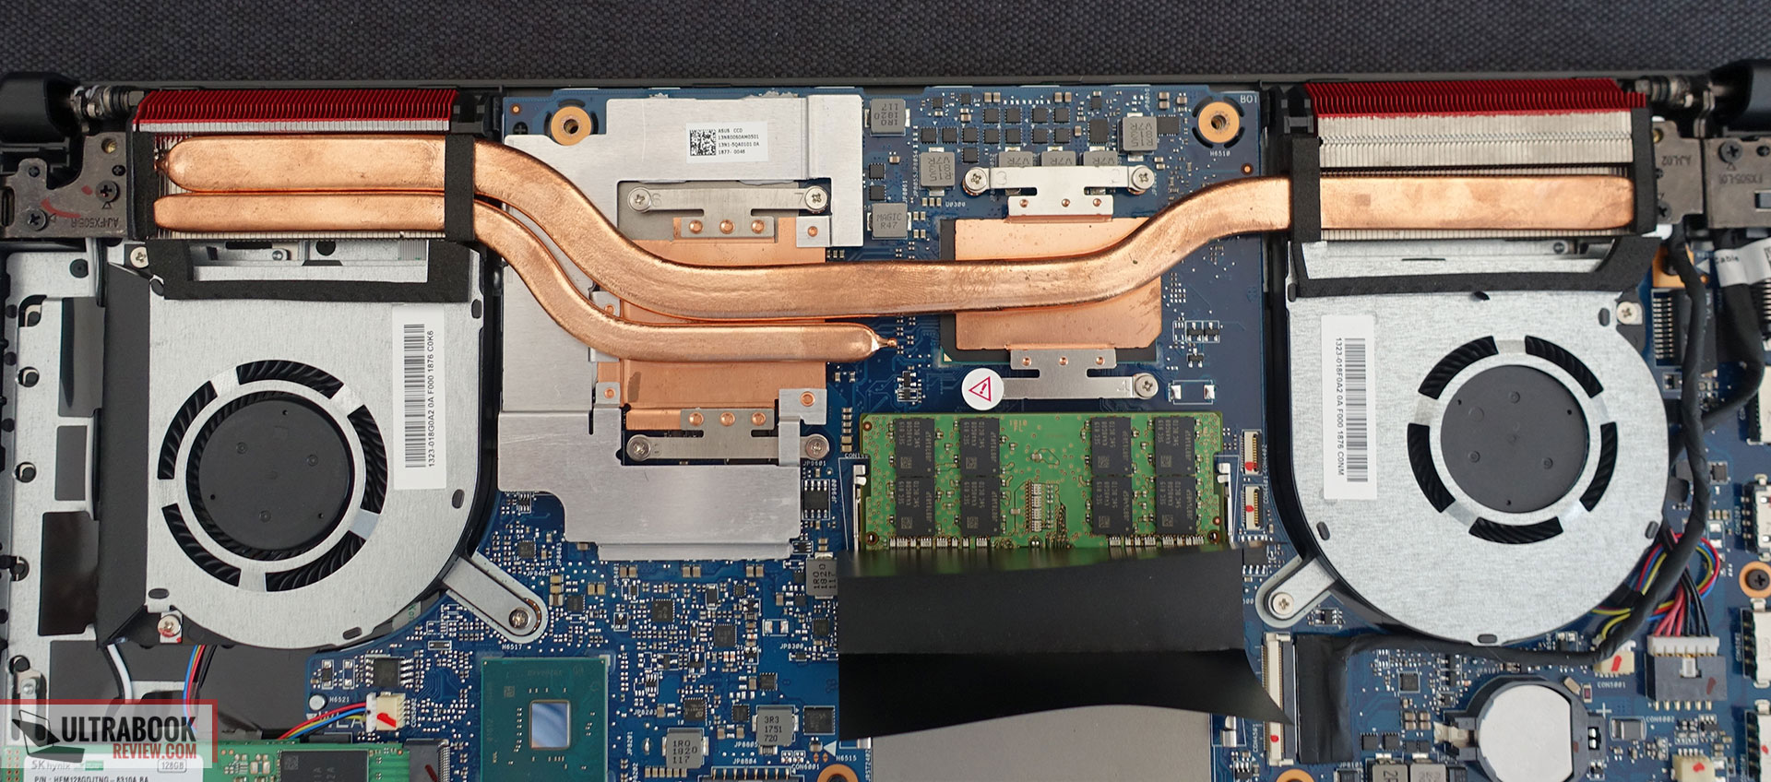](https://www.ultrabookreview.com/wp-content/uploads/2018/08/cooling-4.jpg)

However, the CPU performs better on the FX505, and on a closer look we notice that the fans on the updated model are different, there’s a different layout of those two heatpipes, and the plate on top of the CPU is longer and attached to the motherboard in 4 points, not in 3 points like on the FX504. These small changes explain why the FX505 handles CPU intensive loads better, but the overall design also explains why both the CPU and GPU heat-up with games and combined taxing chores, where the rather simplistic cooling system barely manages to keep them at bay.

Keep in mind we tested the GTX 1050 Ti version here, but Asus also offers an FX505GM model with GTX 1060 graphics, and you should definitely look into how that one performs if you’re interested in it, as I’d expect some surprises.

**Update:** The GTX 1060 laptops get an upgraded cooling design, with extra heapipes, and you can find how the GTX 1060 performs on this chassis [from our review of the larger TUF FX705GM series](https://www.ultrabookreview.com/21873-asus-tuf-fx705-review/#a5).

In comparison, [the ROG GL504 gets a more complex cooling solution](https://www.ultrabookreview.com/20928-asus-rog-gl504gm-review/#a7), which allows the components to run cooler.

I already mentioned the fan profiles above, but here’s what you should expect with gaming:

* Silent – up to 42 dB at head-level, diminished performance;
* Balanced – up to 52 dB at head level, good performance;
* Overboost – Up to 54 dB at head level, similar performance and temperatures.

That’s why we’ve tested outer-case temperatures in games on Balanced mode, and overall recommend keeping this laptop on Balanced mode all the time. The FX505 remains cool and quiet with daily use, and doesn’t get very hot with games either, but the hottest part is around the UIO keys and not on top of the keyboard, which can get uncomfortable in warmer environments.

There’s little to complain about the fans’ management, as they are mostly inactive with daily use, kick in with multitasking and ramp-up quickly with demanding loads, but also ramp down just as quickly once those loads end.

I should also add that we didn’t notice any electronic noise or coil whining on our sample, but these are a lottery and there’s no guarantee you won’t run into them on your unit.

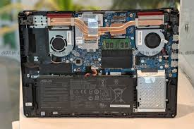

Gaming [motherboards](https://en.wikipedia.org/wiki/Motherboard) are differentiated from their normal counterparts by being created with case windows in mind; having more visually appealing designs, sturdier materials, and, in some models, built-in [LED](https://en.wikipedia.org/wiki/Light-emitting_diode) lighting.They also have the capability to [overclock](https://en.wikipedia.org/wiki/Overclocking) certain models of CPUs, and an increased number of various connection ports

**Final thoughts**

The Asus TUF Gaming FX505 is without a shadow of a doubt one of the better mid-range gaming laptops you’ll find in stores in the second part of 2018 and onwards.

It’s a complete revamp of the TUF FX504 line and is a more compact computer with nicer looks, an RGB keyboard, faster wireless, an optional IPS 144 Hz screen and slightly improved cooling, just enough to eliminate the throttling issues people complain about on the Core i7 versions of the FX504GE and GM, at least based on our experience with this review unit.

Despite all these, the FX505 remains Asus’s budget line of gaming notebooks, which means that potential buyers still have to accept an only average IPS screen with reduced maximum brightness, an average sized battery, rather poor speakers and a cooling system that barely keeps up with the hardware and allows both the CPU and GPU to run well on this i7/GTX 1050 Ti model, but at high

Pricing is going to be a decisive factor when choosing between one of these FX505s and the competition ([Acer Nitro 5](https://www.ultrabookreview.com/19469-acer-nitro-5-review-coffee-lake/), [Lenovo legion Y530](https://www.ultrabookreview.com/22037-lenovo-legion-y530-review/), Dell G7 Gaming). On top of that, if you’re interested in the TUF FX505GM versions, you should make sure that the GTX 1060 is going to perform as well in this chassis, even with its improved cooling. On the other hand, if your budget allows, the [ROG Strix Scar II](https://www.ultrabookreview.com/20928-asus-rog-gl504gm-review/), the MSI GE63 Raider or the HP Omen 5 remain better mid-range gaming laptops, but for the most part not better-value buys.

[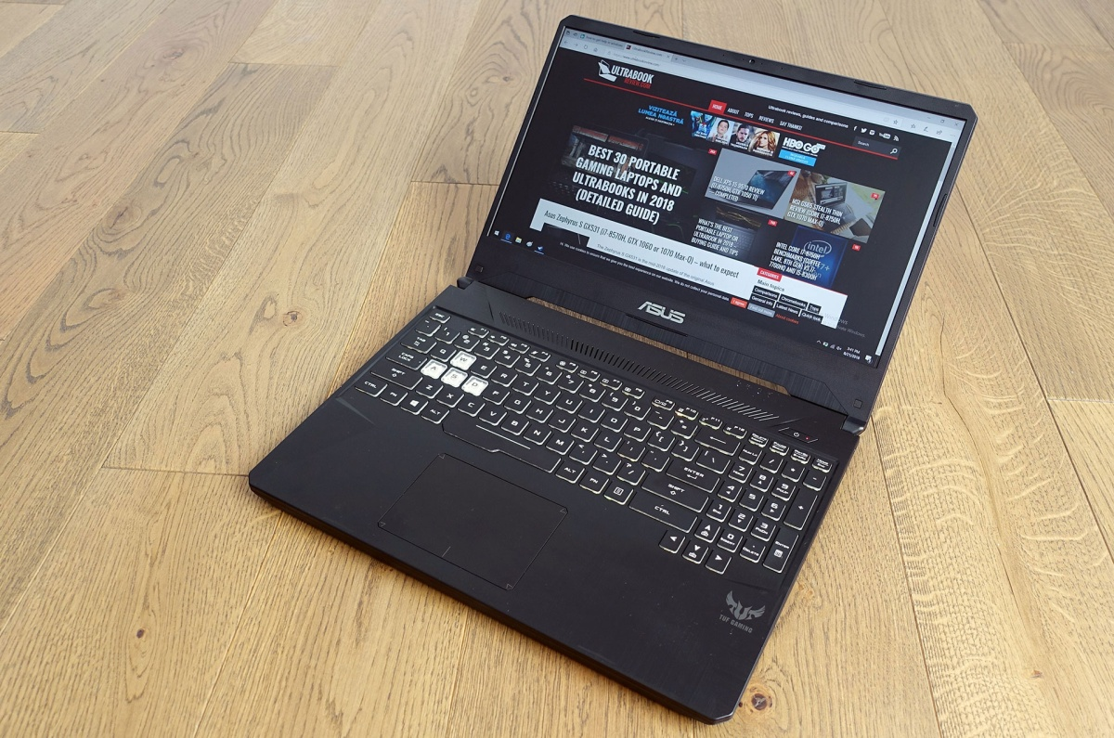](https://www.ultrabookreview.com/wp-content/uploads/2018/08/design-interior-1-2.jpg)

We’ll wrap up this review of the Asus TUF Gaming FX505 GE here, but the comments section below awaits your input and questions if you need any help with this particular notebook, or any of the alternatives out there.

Quotation





**THANK YOU...**

Proc